Report on local seminar at Klacksörarna 20220618

103 people participated according to participants list. Of them, 10 were officials or politicians. (Pic. 1-5)
Due to the difficulty of getting visitors with their own boat to sign up, the total number is estimated at about 200 people.

The seminar was conducted according to the agenda. (Pic. 6)

Photos taken on spot. (Pic. 7-)

Pic. 1

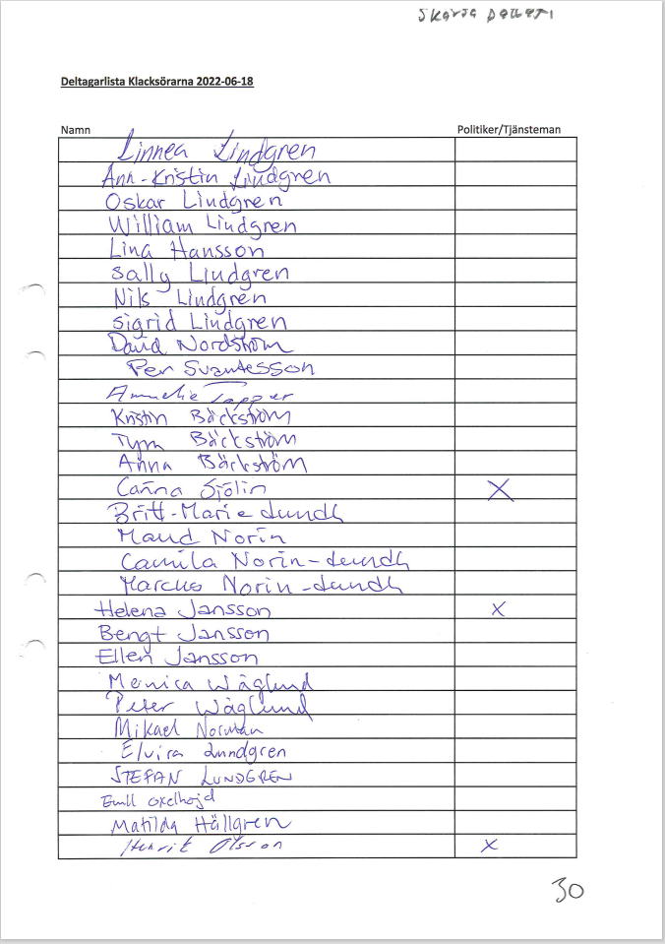

Pic. 2

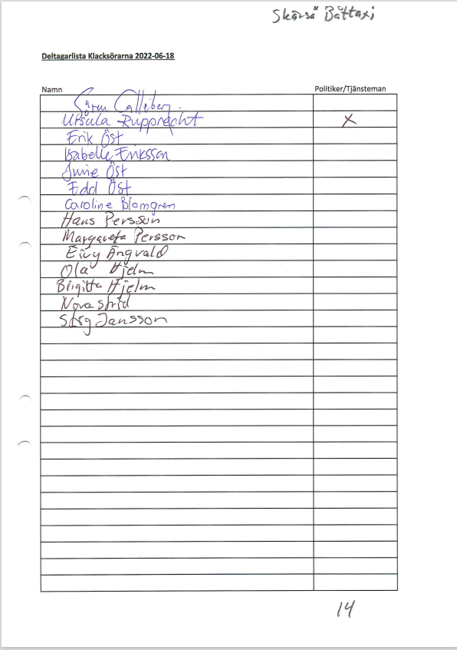

Pic. 3

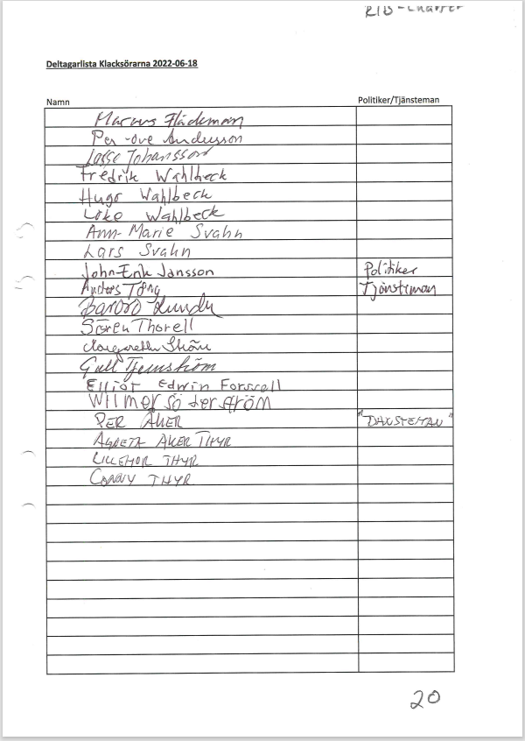

Pic. 4

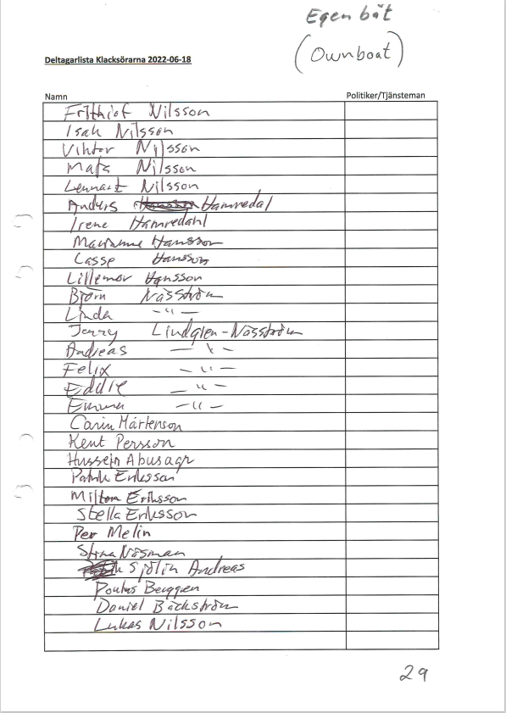

Pic. 5

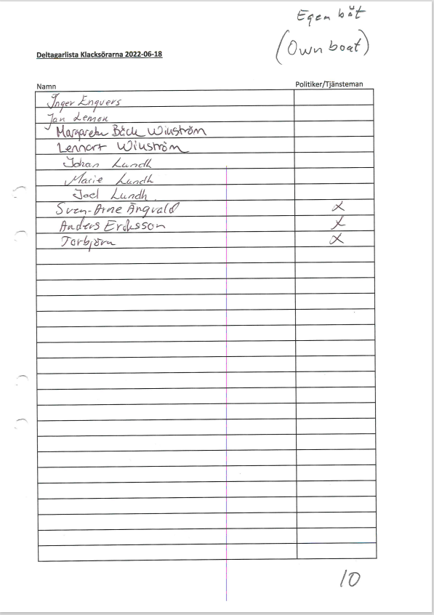

Pic. 6

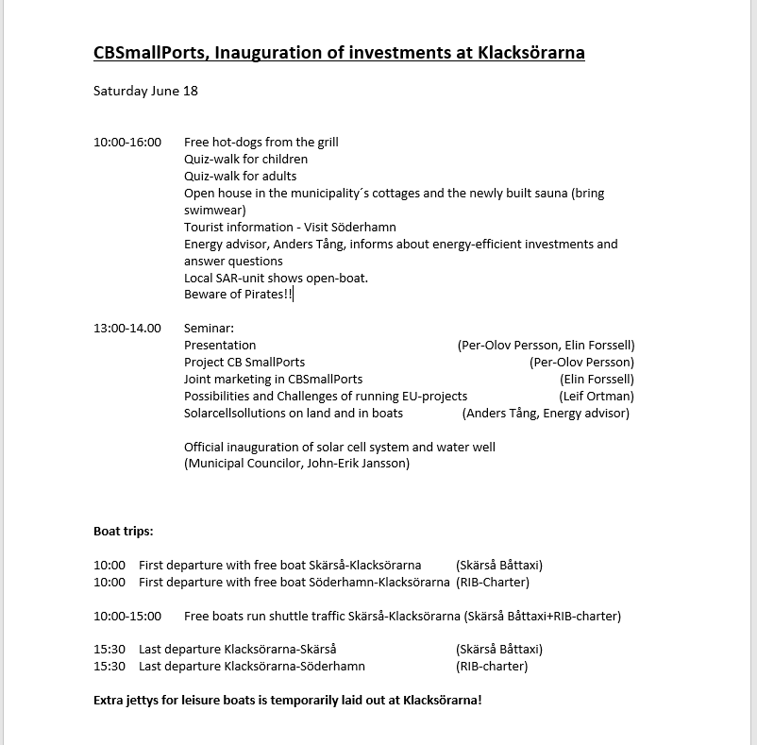

Pic. 7-

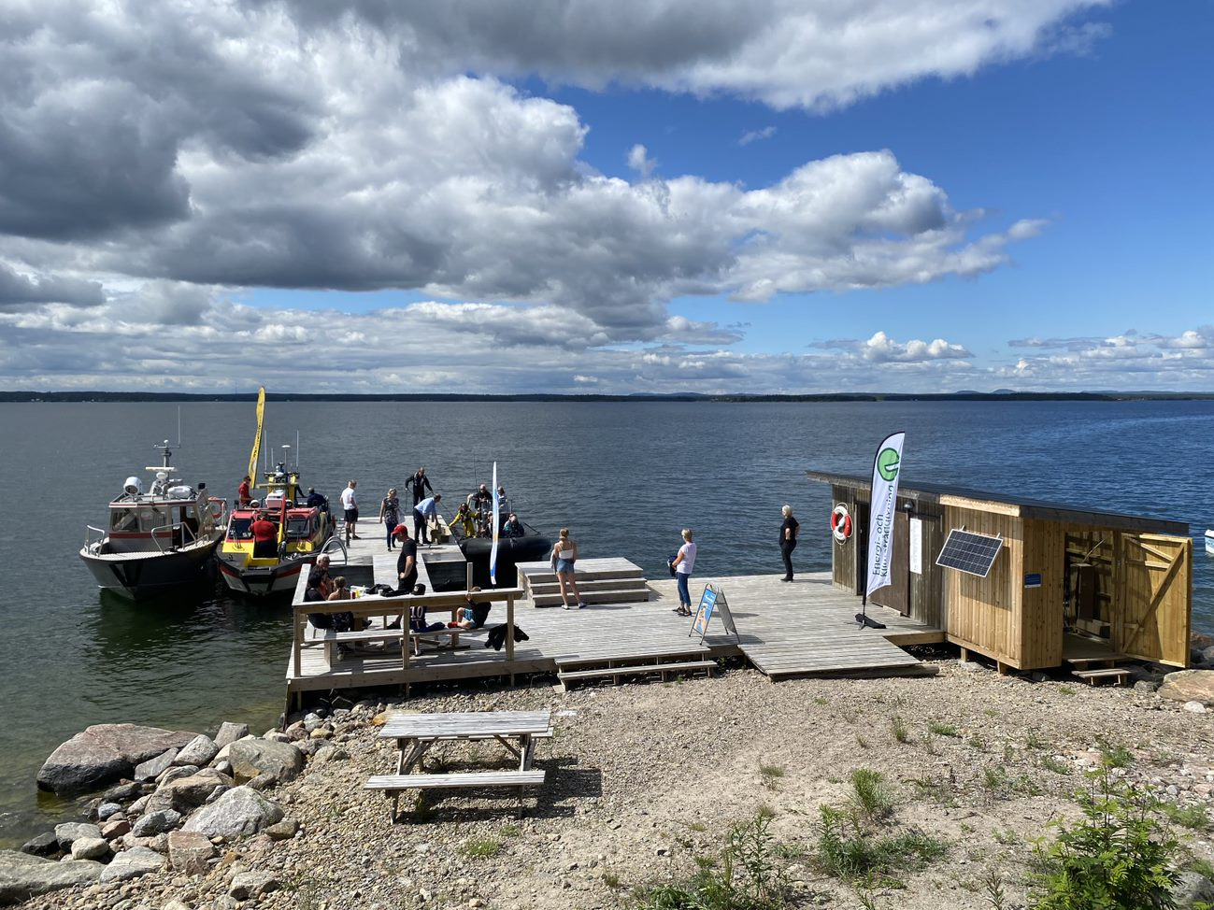

Visitors arriving in chartered RIB-boat……..

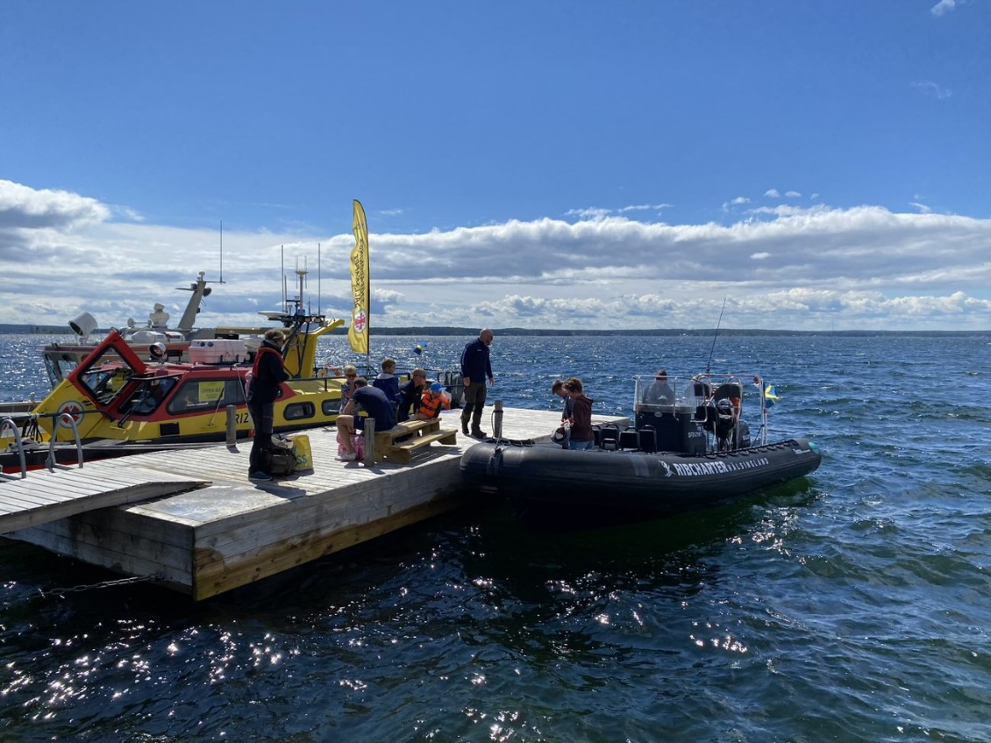
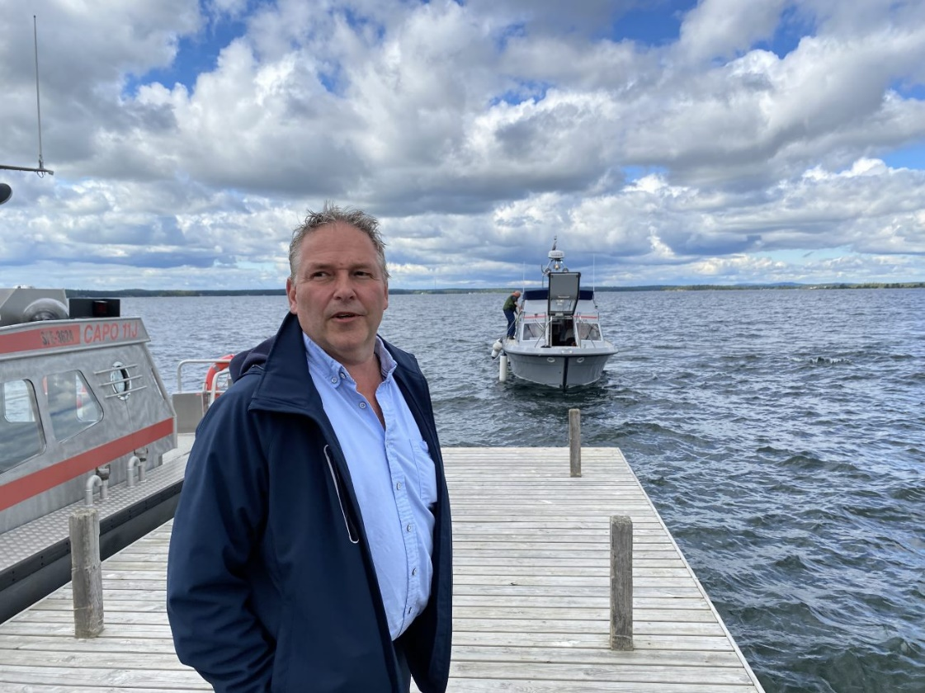

…taxi boat…….

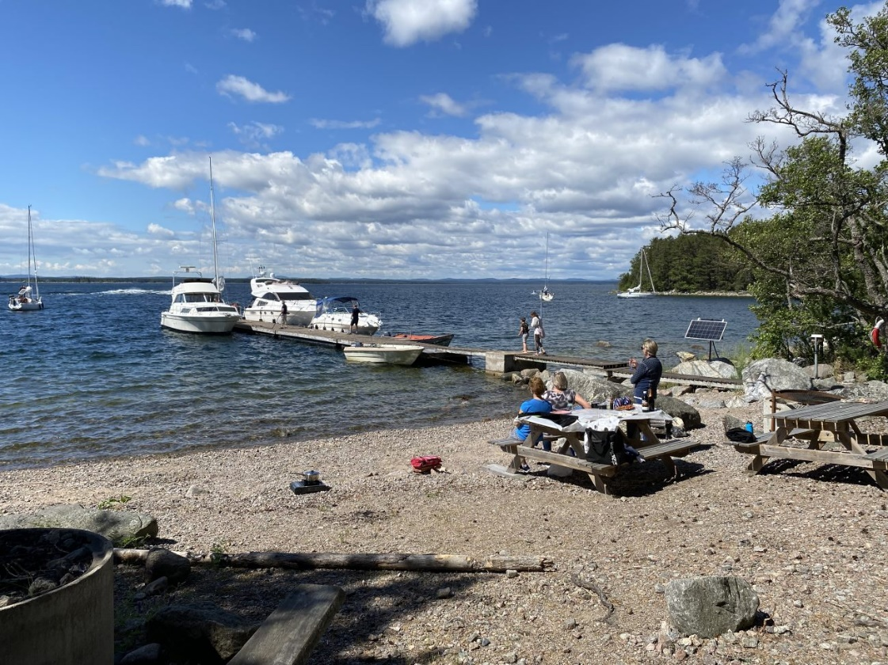

….and by own boats.

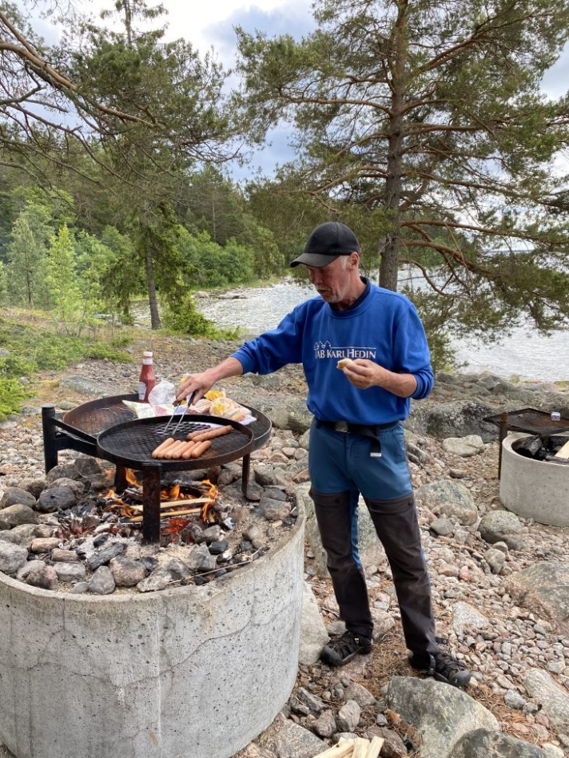

Hot dogs served from the grill.

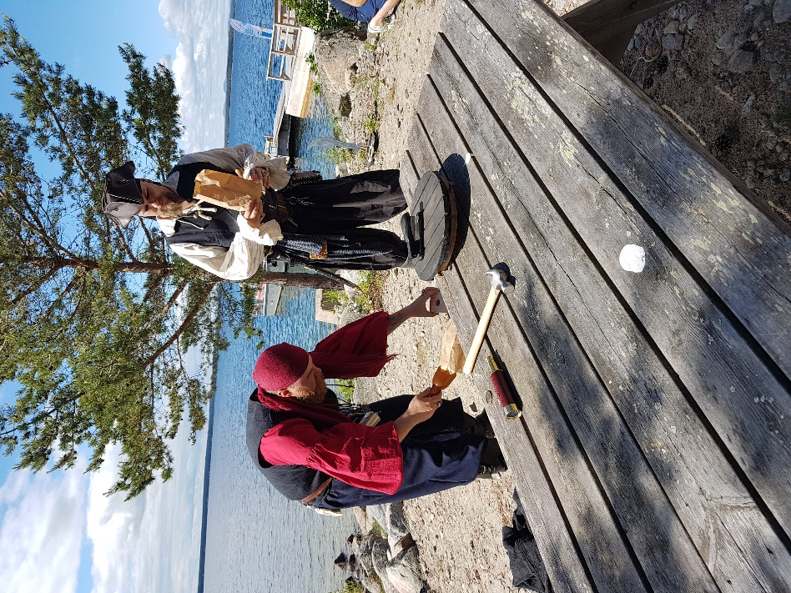

Pirates fooling around.
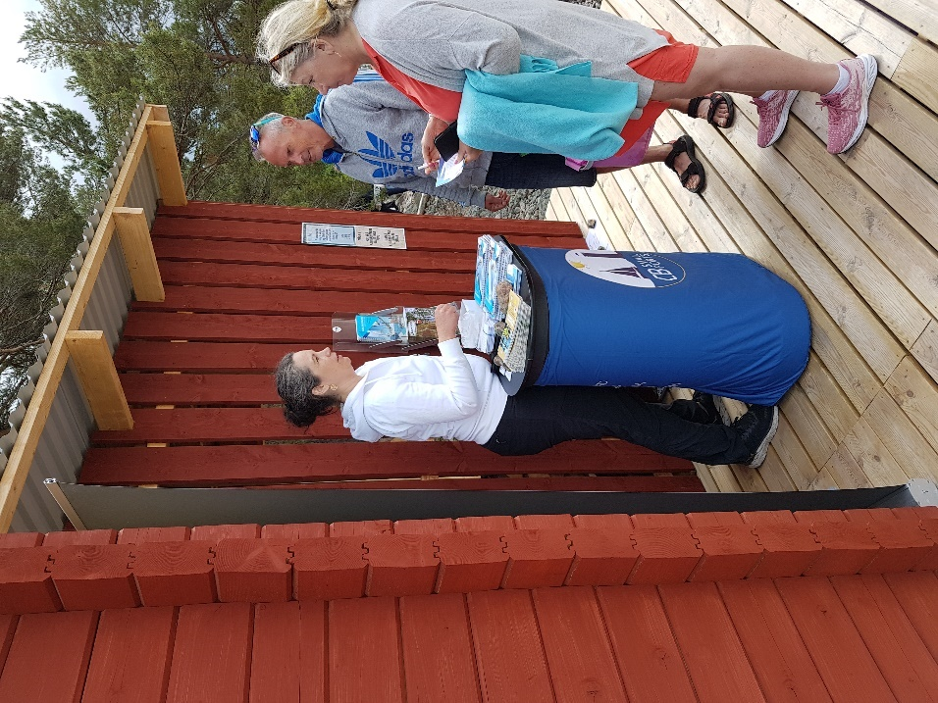

Tourist information.

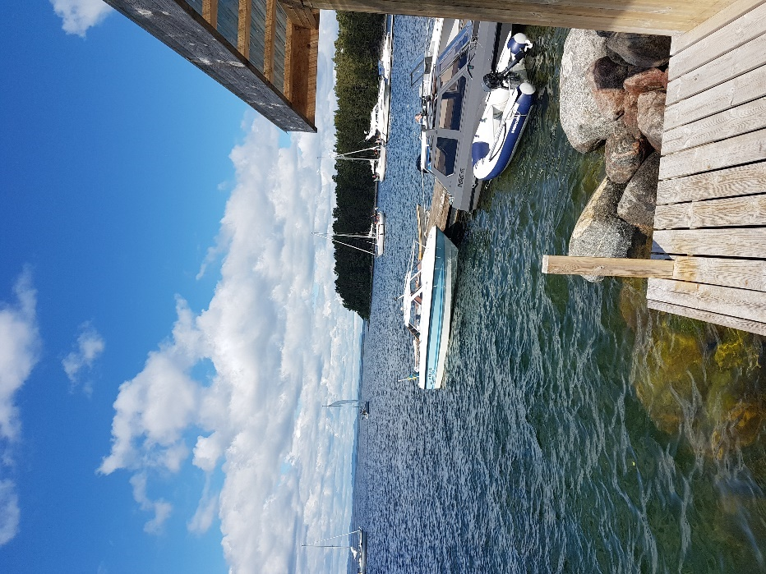

Even the extra jetty was filled.
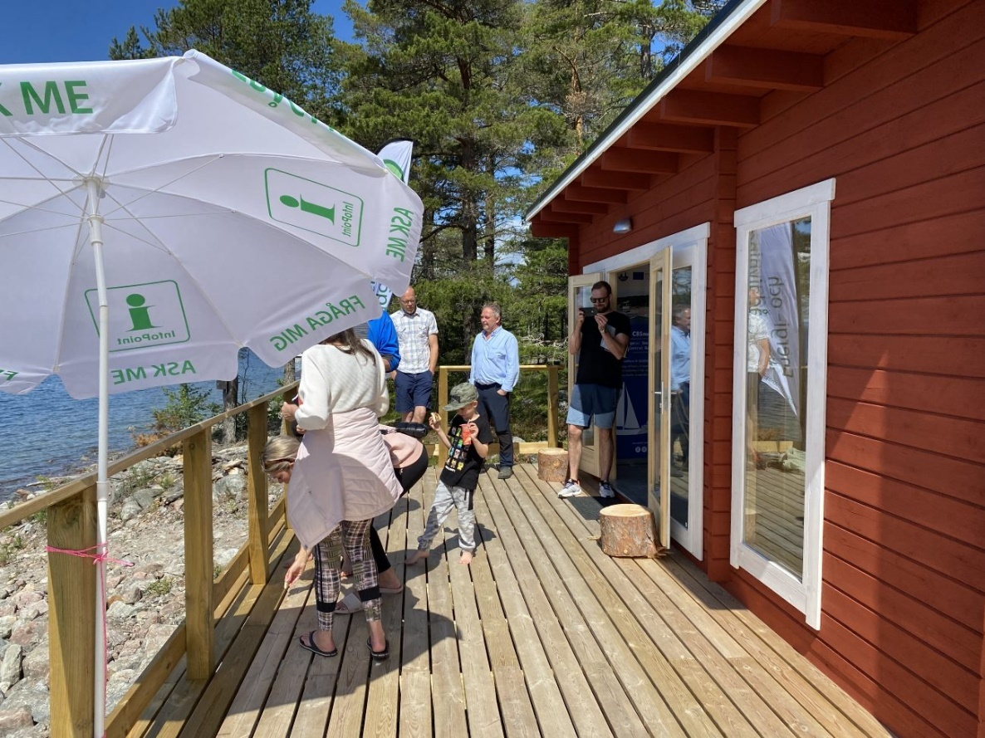

Energy advicing.

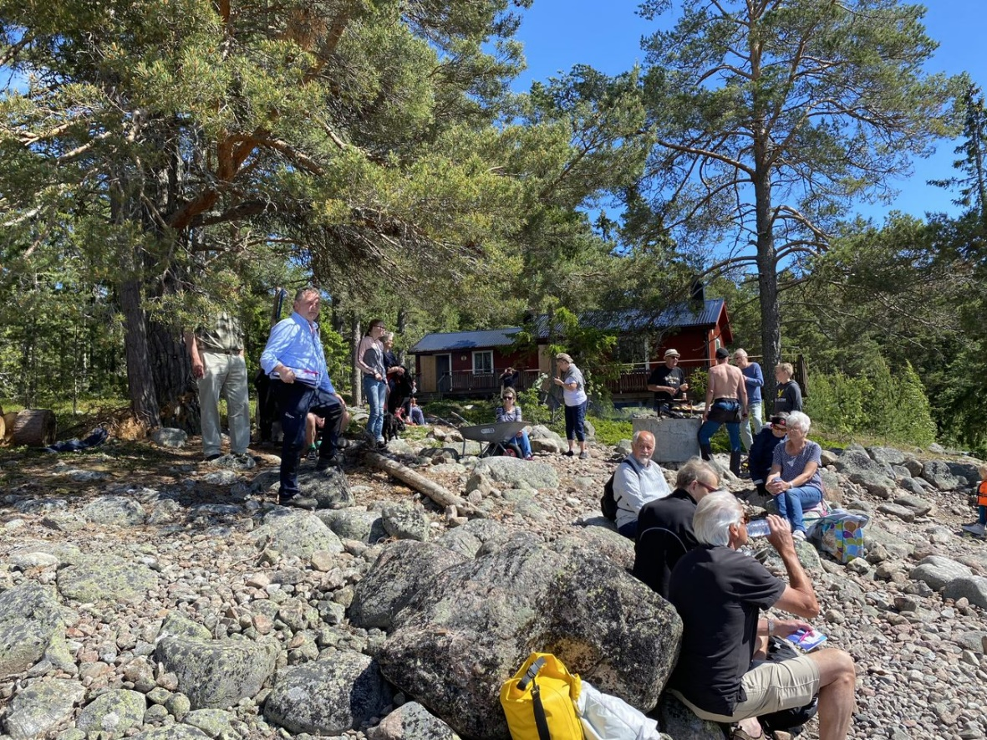

Seminar starts with presentation and info of the project…….

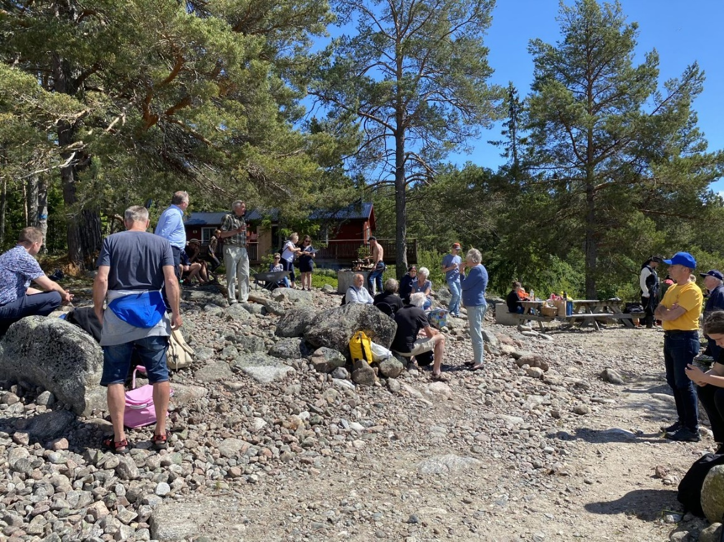

…continuing with challenges and possibilities…….

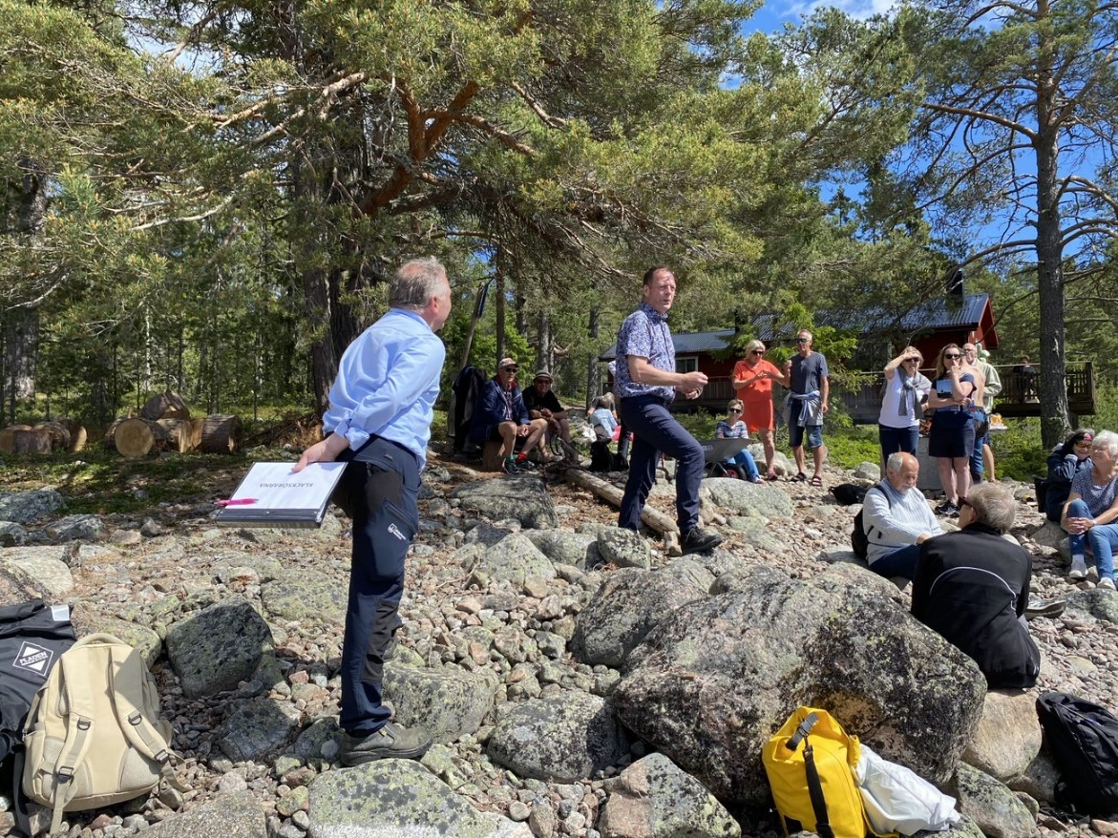

…and, of course, the official inaguration by the municipal councilor.

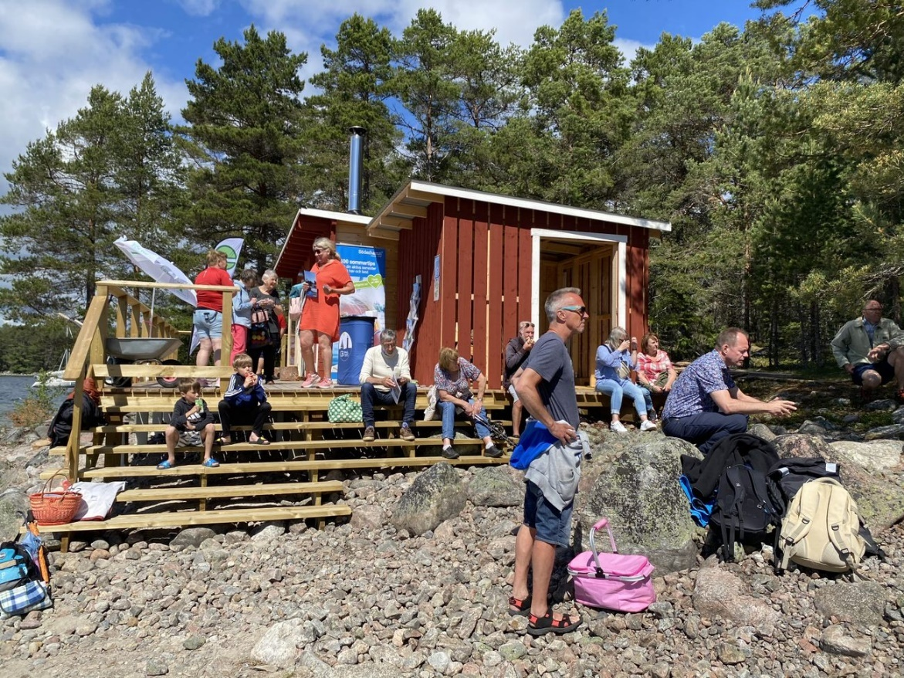

Before the wind and rain came, the weather was really nice and hot.

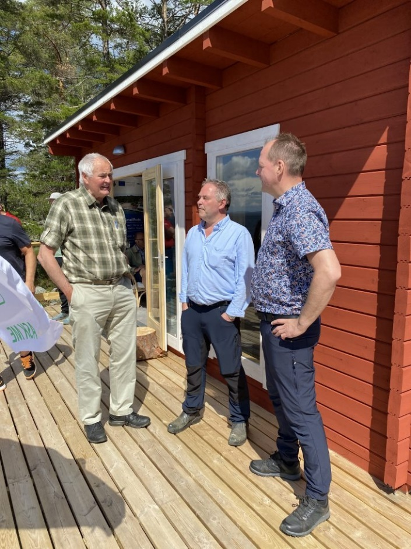

Discussion about similarities and differences in Söderhamn and Gotland.

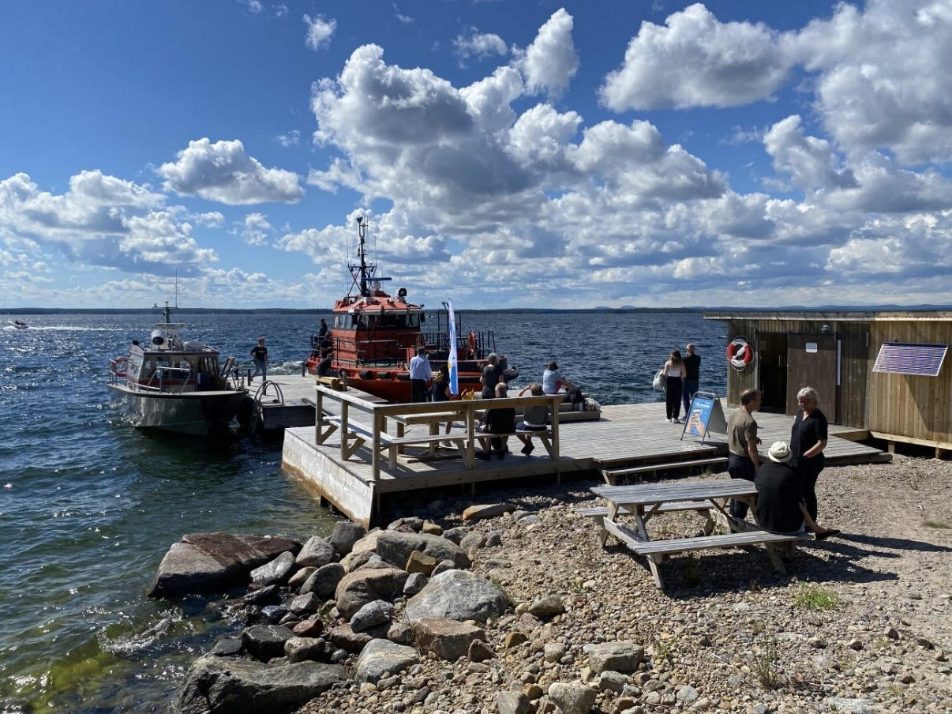

The regional Pilot boat made an unannounced visit. Also they opened the doors for the curious ones.

